# 2. INTEGRATOR AND DIFFERENTIATOR

## 2.1 OBJECTIVE

1. Design an integrator for a frequency of 500 Hz, given R=1KΩ, C=0.1 µF and

Rf = 1MΩ. Conduct the experiment and plot integrated output waveforms for various input waveforms and analyse

1. Design a differentiator for a frequency of 500 Hz, given R=1KΩ, and C=0.1µf and R1 = 470Ω. Conduct the experiment and plot integrated output waveforms for various input waveforms and analyse

## 2.2 HARDWARE REQUIRED

|  |  |  |  |
| --- | --- | --- | --- |
| **S.No** | **Equipment/Component name** | **Specifications/Value** | **Quantity** |
| 1 | IC 741 | Refer data sheet in appendix | 1 |
| 2 | Cathode Ray Oscilloscope | (0 – 20MHz) 1 | 1 |
| 3 | Resistors | 1K Ω  1M Ω  10 K Ω  470 Ω | 1 1  1  1 |
| 4 | Capacitors | 0.1µf | 2 |
| 5 | Dual Regulated power supply | (0 -30V), 1A | 1 |
| 6 | Function Generator | (0-2) MHz | 1 |

## 2.3 THEORY

In this laboratory experiment, you will learn several basic ways in which an op-amp can be connected using *negative feedback* to *stabilize the gain* and increase the *frequency response*. The extremely high *open-loop gain* of an op-amp creates an unstable situation because a small noise voltage on the input can be amplified to a point where the amplifier in driven out of its linear region. Also unwanted oscillations can occur. In addition, the open-loop gain parameter of an op-amp can vary greatly from one device to the next. Negative feedback takes a portion of output and applies it back out of phase with the input, creating an effective reduction in gain. This *closed-loop gain* is usually much less than the open-loop gain and independent of it.

### 2.3.1 Integrator

An op-amp integrator simulates mathematical integration which is basically a summing process that determines the total area under the curve of a function ie., the integrator does integration of the input voltage waveform. Here the input element is resistor and the feedback element is capacitor as shown in fig.2-1.

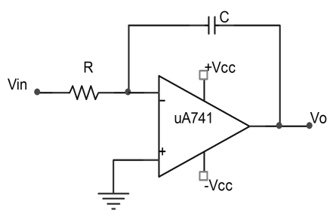

### *Fig.2-1 Basic op-amp integrator*

The output voltage is given by

$$V_{0}=\frac{-1}{RC}\int_{0}^{t}{V_{s}dt}+V_{c}(t=0)$$

Where VC (t=0) is the initial voltage on the capacitor. For proper integration, RC has to be much greater than the time period of the input signal.

It can be seen that the gain of the integrator decreases with the increasing frequency so, the integrator circuit does not have any high frequency problem unlike a differentiator circuit. However, at low frequencies such as at dc, the gain becomes infinite. Hence the op-amp saturates (ie., the capacitor is fully charged and it behaves like an open circuit). A practical integrator circuit is shown in Fig. 2-2.

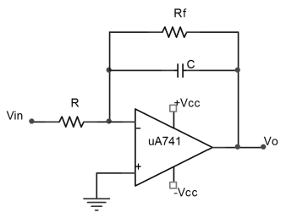

### *Fig.* 2*-2 Practical op-amp integrator*

#### 2.3.2 Differentiator

An op-amp differentiator simulates mathematical differentiation, which is a process of determining the instantaneous rate of change of a function. Differentiator performs the reverse of integration function. The output waveform is derivative of the input waveform. Here, the input element is a capacitor and the feedback element is a resistor. An ideal differentiation is shown in fig. 2-3.

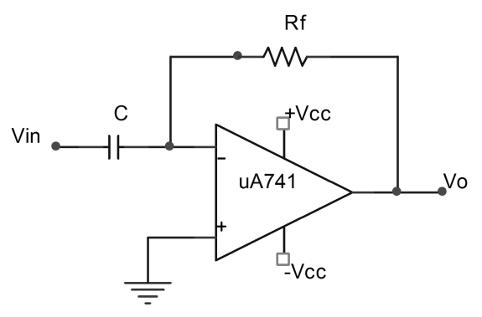

***Fig.2-3*** *Basic op-amp differentiator* The output voltage is given by

*VO* =−*RC $\frac{dV_{s}}{dt}$*

For proper differentiation, RC has to be much smaller than the time period of the input signal. It can be seen that at high frequencies a differentiator may become unstable and break into oscillation. Also, the input impedance of the differentiator decreases with increase in frequency, thereby making the circuit sensitive to high frequency noise. So, in order to limit the gain of the differentiator at high frequencies, the input capacitor is connected in series with a resistance R1 and hence avoiding high frequency noise and stability problems. A practical differentiator circuit is shown in fig. 2-4.

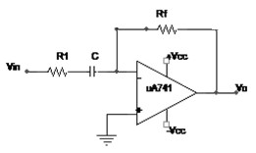

#### *Fig. 2-4 Practical op-amp differentiator*

##### 2.3.3. Design Constraints

###### Integrator circuit

* The output of the integrator cannot rise indefinitely as the output will be limited.
* The output of the op amp integrator will be limited by supply voltage.
* When designing one of these circuits, it may be necessary to limit the gain or increase the supply voltage to accommodate the likely output voltage swings.
* While small input voltages and for short times may be acceptable, care must be taken when designing circuits where the input voltages are maintained over longer periods of time.

## Differentiator circuit

* **Output rises with frequency:** One of the key facts of having a series capacitor is that it has an increased frequency response at higher frequencies. The differentiator output rises linearly with frequency, although at some stage the limitations of the op amp will mean this does not hold good. Accordingly precautions may need to be made to account for this. The circuit, for example will be very susceptible to high frequency noise, stray pick-up, etc.
* **Component value limits:** It is always best to keep the values of the capacitor and particularly the resistor within sensible limits. Often values of less than 100kΩ for the resistor are best. In this way the input impedance of the op amp should have no effect on the operation of the circuit.\

## 2.4 PRE LAB QUESTIONS

1. Op-amp is used mostly as an integrator than a differentiator. Why?

### 2. Why open-loop op-amp configurations are not used in linear applications?

3. Determine the output voltage of each amplifier in Fig (a).

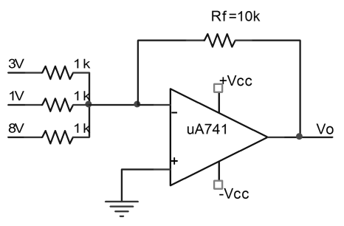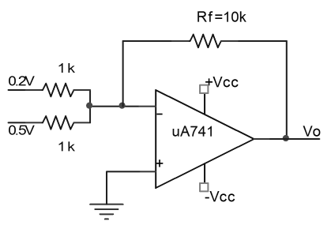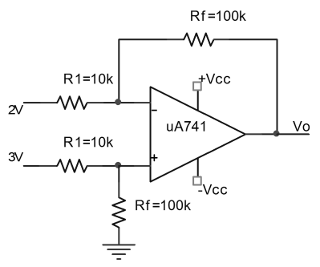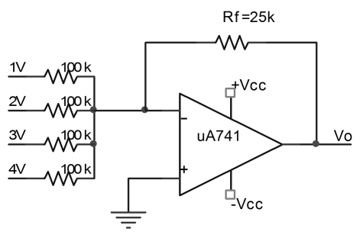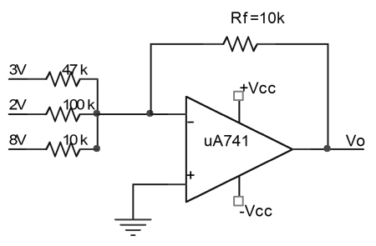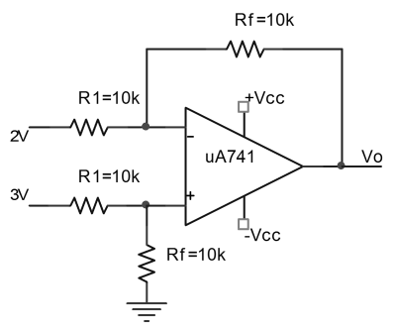

***Fig.(a)***

## 2.5 EXPERIMENT

## (1) Integrator

1.1 Assemble an integrator circuit with R=1KΩ and C=0.1µf. Connect Rf of value 1MΩ across the capacitor.

1.2 Feed +1V, 500Hz square wave input.

1.3 Observe the input and output voltages on a CRO.

1.4 Determine the gain of the circuit and tabulate the readings in table. Model waveform is shown.

1.5 Plot the input and output voltages on the same scale on a linear graph sheet.

## (2) Differentiator

2.1 Assemble a differentiator circuit with R=1KΩ and C=0.1µf. Connect a resistor R1 of value 470Ω between the source and the capacitor.

2.2 Feed +1V, 500Hz square wave input.

2.3 Observe the input and output voltages on a CRO.

2.4 Determine the gain of the circuit and tabulate the readings in table. Model waveform is shown.

2.5 Plot the input and output voltages on the same scale on a linear graph sheet.

|  |  |  |  |  |
| --- | --- | --- | --- | --- |
| **op-amp**  **configuration / circuit** | **Input signal** | | **Output signal** | |
| **Amplitude** | **Frequency** | **Amplitude** | **Frequency** |
| Integrator |  |  |  |  |
| Differentiator |  |  |  |  |

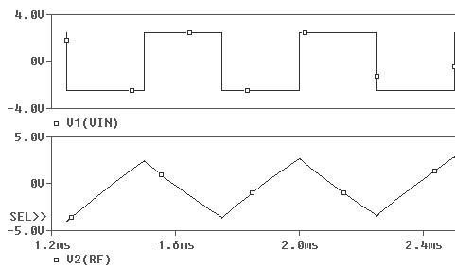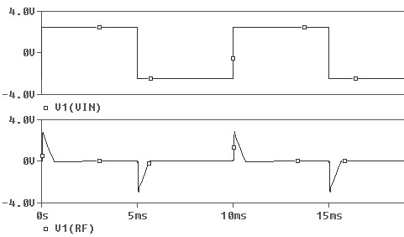

***a)***

### *(b)*

***Fig.*2.5 *Waveform*** *for (a) op-amp integrator, (b) op-amp differentiator*

#### 2.6. POST LAB QUESTIONS

1. What are the limitations of an ordinary op-amp differentiator? How that will be eliminated in practical differentiator?
2. Determine the input and output impedances of each amplifier.
3. (a) What is the normal output voltage in fig. 2-6?
   1. What is the output voltage if R2 opens?
   2. What happens if R5 opens?

***Fig. 2***

***-***

6

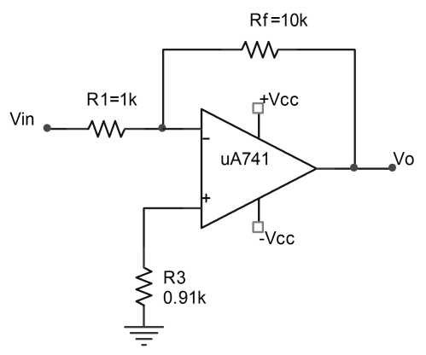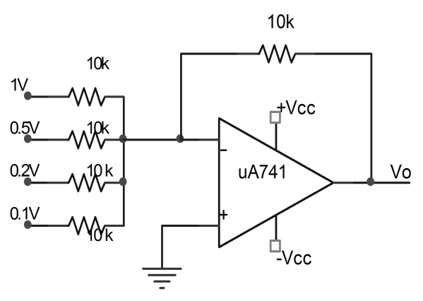

**Result:**